SIMATS ENGINEERING
ASSESSMENT TOOL 2

COURSE NAME: Database Management Systems
COURSE CODE: CSA05

COURSE OUTCOME COVERED

CO1: Analyse DBMS architecture, different data models, schema types, and design ER/EER diagrams, relational schemas for case-based scenarios by identifying entities and relationships. (BL1, BL2)

Activity Tool : Concept Mapping (Medium)
Assessment Tool Weightage: 20%

QUESTIONS
Q.No | Question | Bloom's Level
1 | Construct a concept map linking the following terms: DBMS, Schema, Instance, Data Model, ER Diagram, Entity, Attribute, Relationship. | BL2 – Understand
2 | Create a concept map for the three-level ANSI/SPARC architecture showing data independence at each level. | BL2 – Understand
3 | Map the relationship between file-based systems and database systems, highlighting the problems solved by DBMS. | BL2 – Understand
4 | Design a concept map for ER diagram components: entity, weak entity, attribute types, relationship types, and participation constraints. | BL2 – Understand
5 | Construct a concept map comparing Hierarchical, Network, and Relational data models with their key properties. | BL2 – Understand
6 | Develop a concept map for the EER model showing how it extends the basic ER model with generalization, specialization, and aggregation. | BL2 – Understand
7 | Create a visual concept map for the DBMS software architecture, illustrating the flow from user request to data retrieval. | BL2 – Understand
8 | Map the data models discussed in CO1 to real-world applications and explain the suitability of each model. | BL2 – Understand
9 | Construct a concept map for schemas and instances, showing how they relate to physical and logical data independence. | BL2 – Understand
10 | Design a concept map for the roles and responsibilities in a DBMS environment: DBA, End User, Application Developer. | BL1 – Remember

Code of Conduct:

I ____________________ (Name / Reg No) certify that this submission is my original work and that I have adhered to the guidelines specified for this assessment.
I understand that any violation of academic integrity rules will result in disciplinary action.

Signature of the student:

RUBRICS FOR CALCULATION:

Criteria | Weightage | Level 4 (Exemplary) | Level 3 (Proficient) | Level 2 (Developing) | Level 1 (Beginning)
Concept Identification | 25% | Identifies all key concepts from literature accurately and comprehensively | Identifies most key concepts with minor omissions | Identifies limited concepts; some are irrelevant or missing | Fails to identify essential concepts
Linkages | 25% | Establishes clear, meaningful, and accurate relationships between concepts | Shows correct relationships with minor gaps | Relationships are weak, unclear, or partially incorrect | No meaningful relationships established
Organization | 20% | Concepts are well-structured hierarchically with logical flow and grouping | Mostly organized with minor structural issues | Some organization but lacks clear hierarchy | No logical organization or structure
Integration of Literature | 20% | Integrates multiple studies effectively to show connections and comparisons | Shows some integration of literature | Limited integration; mostly isolated concepts | No integration of literature evidence
Clarity | 10% | Concept map is clear, neat, visually structured, and easy to interpret | Generally clear with minor readability issues | Clarity is reduced; difficult to interpret in parts | Poorly presented and hard to understand

1.Construct a concept map linking the following terms: DBMS, Schema, Instance, Data Model, ER Diagram, Entity, Attribute, Relationship

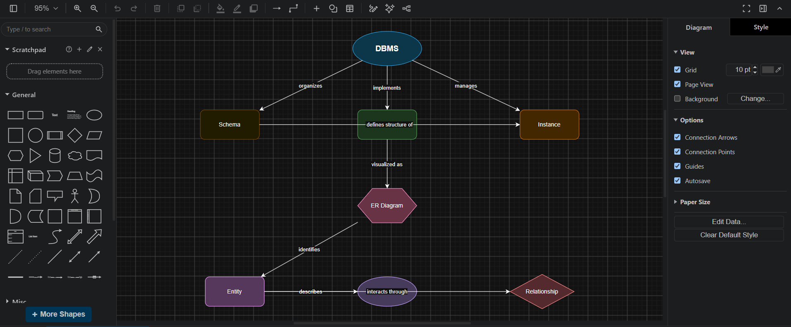
Tool used: https://app.diagrams.net/

• DBMS (Database Management System) is the central component that manages, stores, and retrieves data efficiently.
• A Schema defines the overall structure of the database, including tables, fields, and constraints. It acts as the blueprint of the database.
• An Instance represents the actual data stored in the database at a particular point in time. It changes whenever data is added, updated, or deleted.
• A Data Model provides the logical framework for organizing and representing data in a database.
• An ER (Entity-Relationship) Diagram is a graphical representation of the data model, showing how data is organized and connected.
• An Entity represents a real-world object or concept, such as a Student, Employee, or Product.
• An Attribute describes the properties or characteristics of an entity. For example, a Student entity may have attributes such as Student_ID, Name, and Age.
• A Relationship shows how two or more entities are associated with each other. For example, a Student enrolls in a Course.

2.Create a concept map for the three-level ANSI/SPARC architecture showing data independence at each level.

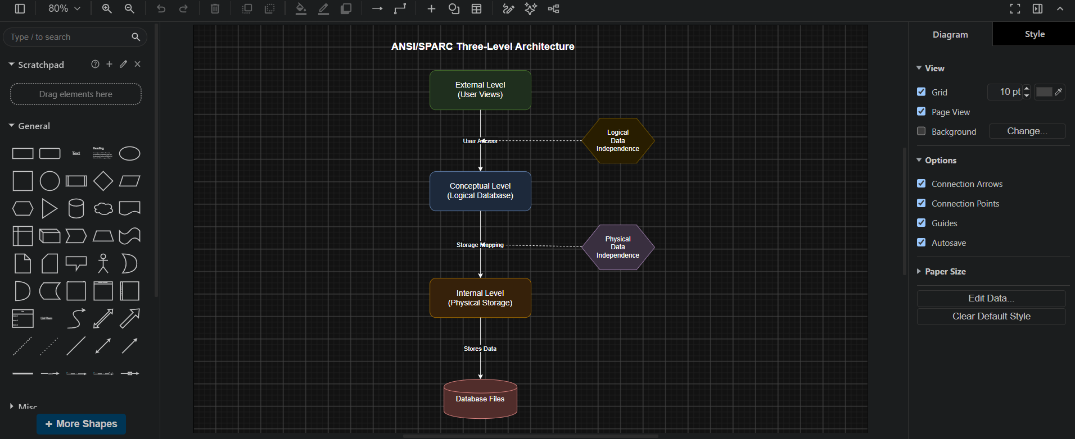
Tool used: https://app.diagrams.net/

The ANSI/SPARC three-level architecture is a database architecture that separates the database into three levels to improve data management and provide data independence.
- External Level (User View):
This is the highest level of the architecture. It provides customized views of the database for different users or applications. Each user can access only the data they need without seeing the entire database.
- Conceptual Level (Logical View):
This level describes the complete logical structure of the database. It defines entities, attributes, relationships, and constraints, independent of how the data is physically stored.
- Internal Level (Physical View):
This is the lowest level of the architecture. It specifies how data is physically stored on storage devices, including file organization, indexing, and access methods.
- Database Files:
These are the actual files on the storage device where the database records are stored and managed.

3.Map the relationship between file-based systems and database systems, highlighting the problems solved by DBMS.
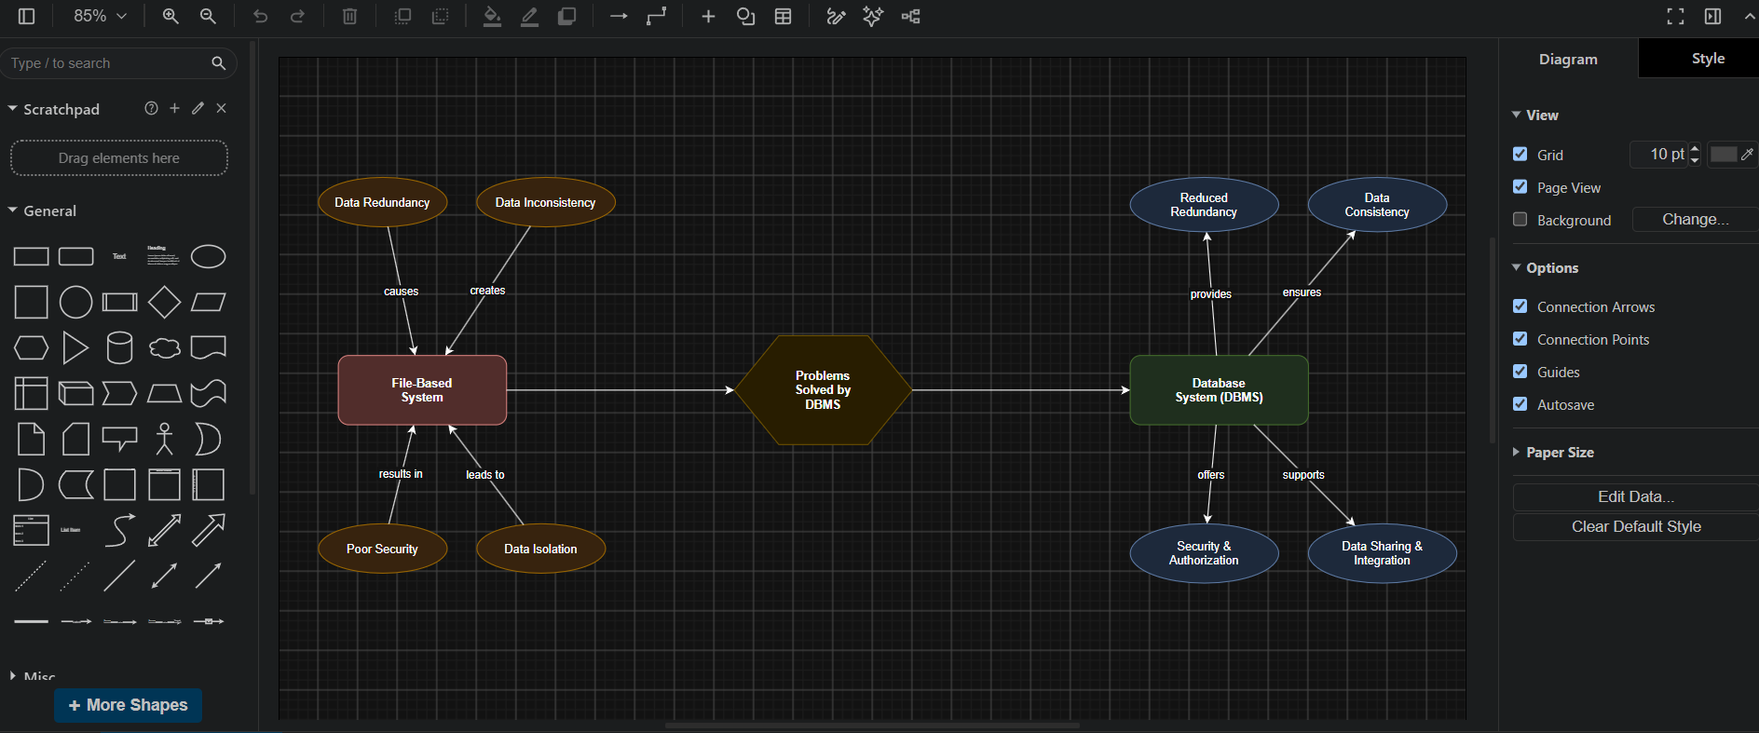
Tool used: https://app.diagrams.net/

The concept map compares a File-Based System with a Database Management System (DBMS).
- File-Based System: Data is stored in separate files for each application, leading to problems such as data redundancy, data inconsistency, poor security, and data isolation.
- Problems Solved by DBMS: The DBMS acts as a central system that overcomes the limitations of file-based systems.
- Database System (DBMS): It provides reduced data redundancy, data consistency, security and authorization, and data sharing with integration.
File-Based System → Problems → DBMS → Improved Database Features

4.Design a concept map for ER diagram components: entity, weak entity, attribute types, relationship types, and participation constraints.

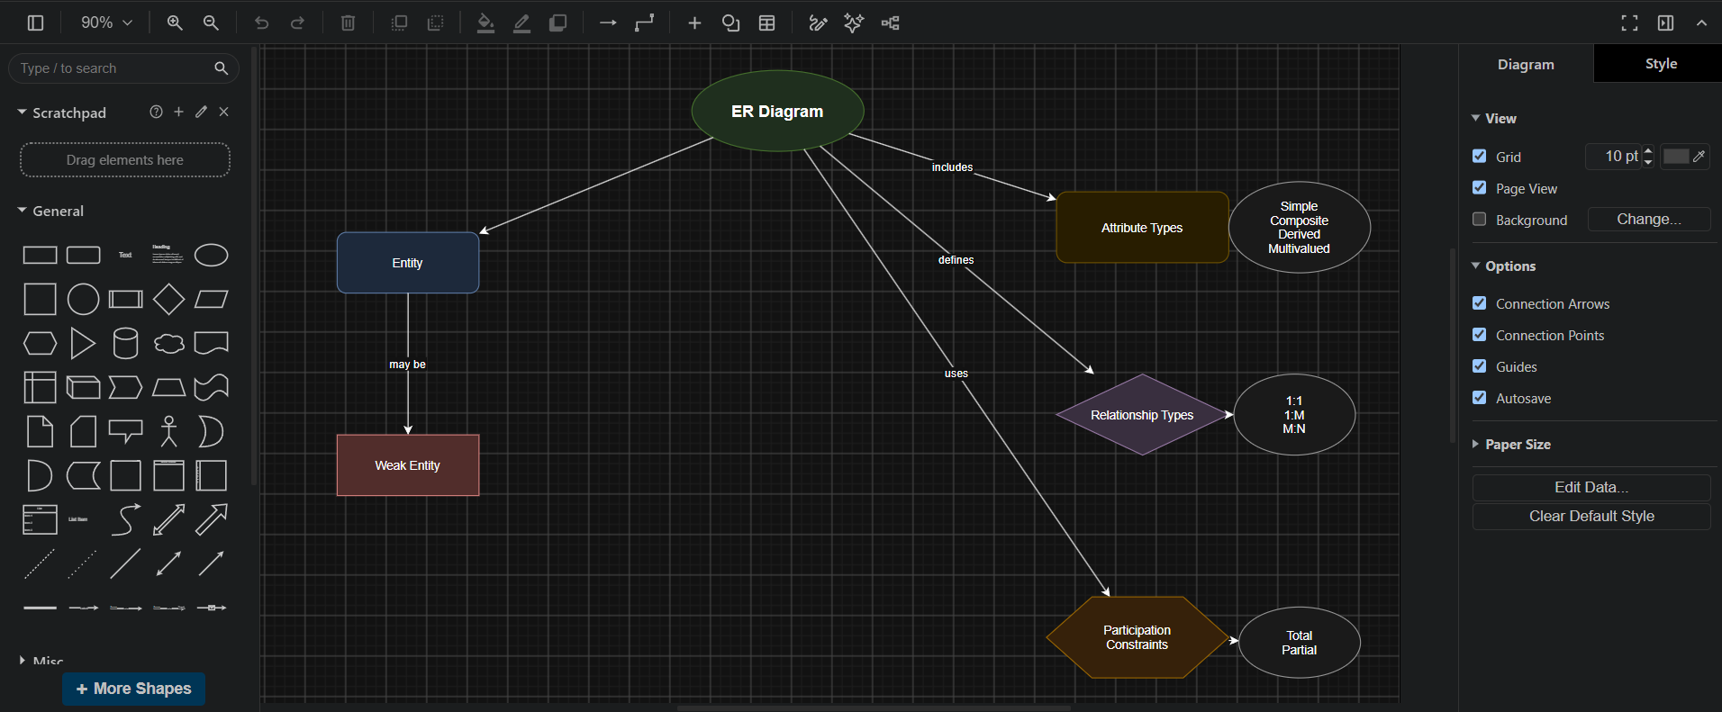
Tool used: https://app.diagrams.net/

The concept map shows the main components of an ER (Entity-Relationship) Diagram, which is used to design a database.
- Entity represents a real-world object, such as a Student or Employee.
- Weak Entity depends on another entity for its identification.
- Attribute Types describe entity properties and include simple, composite, derived, and multivalued attributes.
- Relationship Types define how entities are connected, such as 1:1, 1:M, and M:N.
- Participation Constraints specify whether an entity's participation in a relationship is total (mandatory) or partial (optional)

5.Construct a concept map comparing Hierarchical, Network, and Relational data models with their key properties.

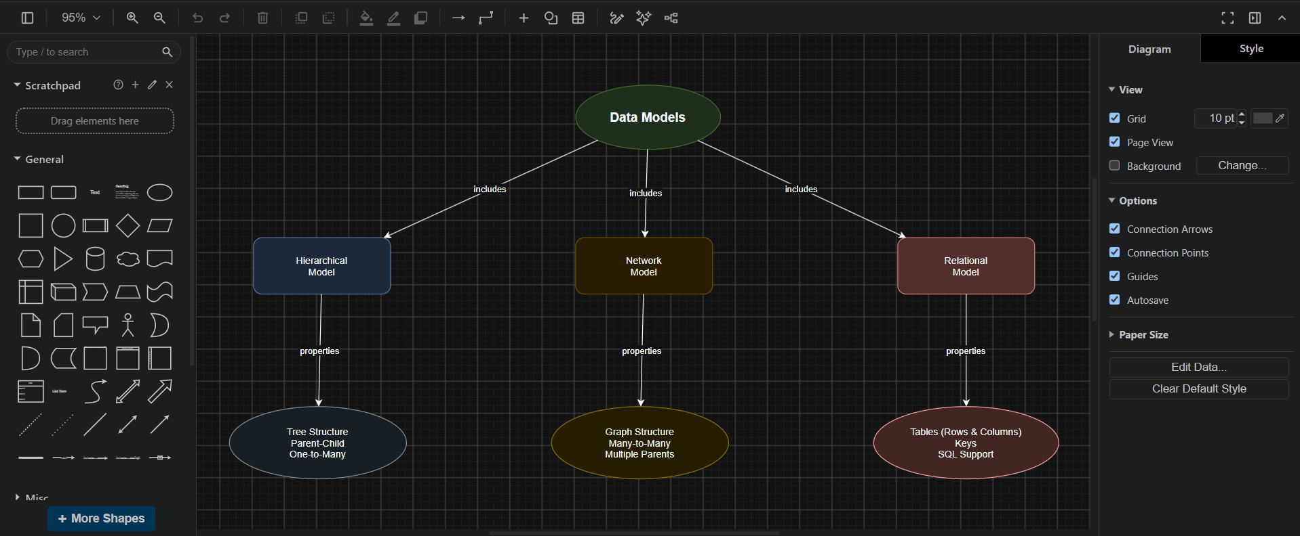
Tool used: https://app.diagrams.net/

This concept map compares the Hierarchical, Network, and Relational data models.
- Hierarchical Model: Organizes data in a tree structure with parent-child relationships. It supports one-to-many relationships.
- Network Model: Organizes data as a graph, allowing many-to-many relationships where a record can have multiple parent records.
- Relational Model: Stores data in tables consisting of rows and columns. It uses primary and foreign keys to establish relationships and supports SQL for data operations.

6.Develop a concept map for the EER model showing how it extends the basic ER model with generalization, specialization, and aggregation

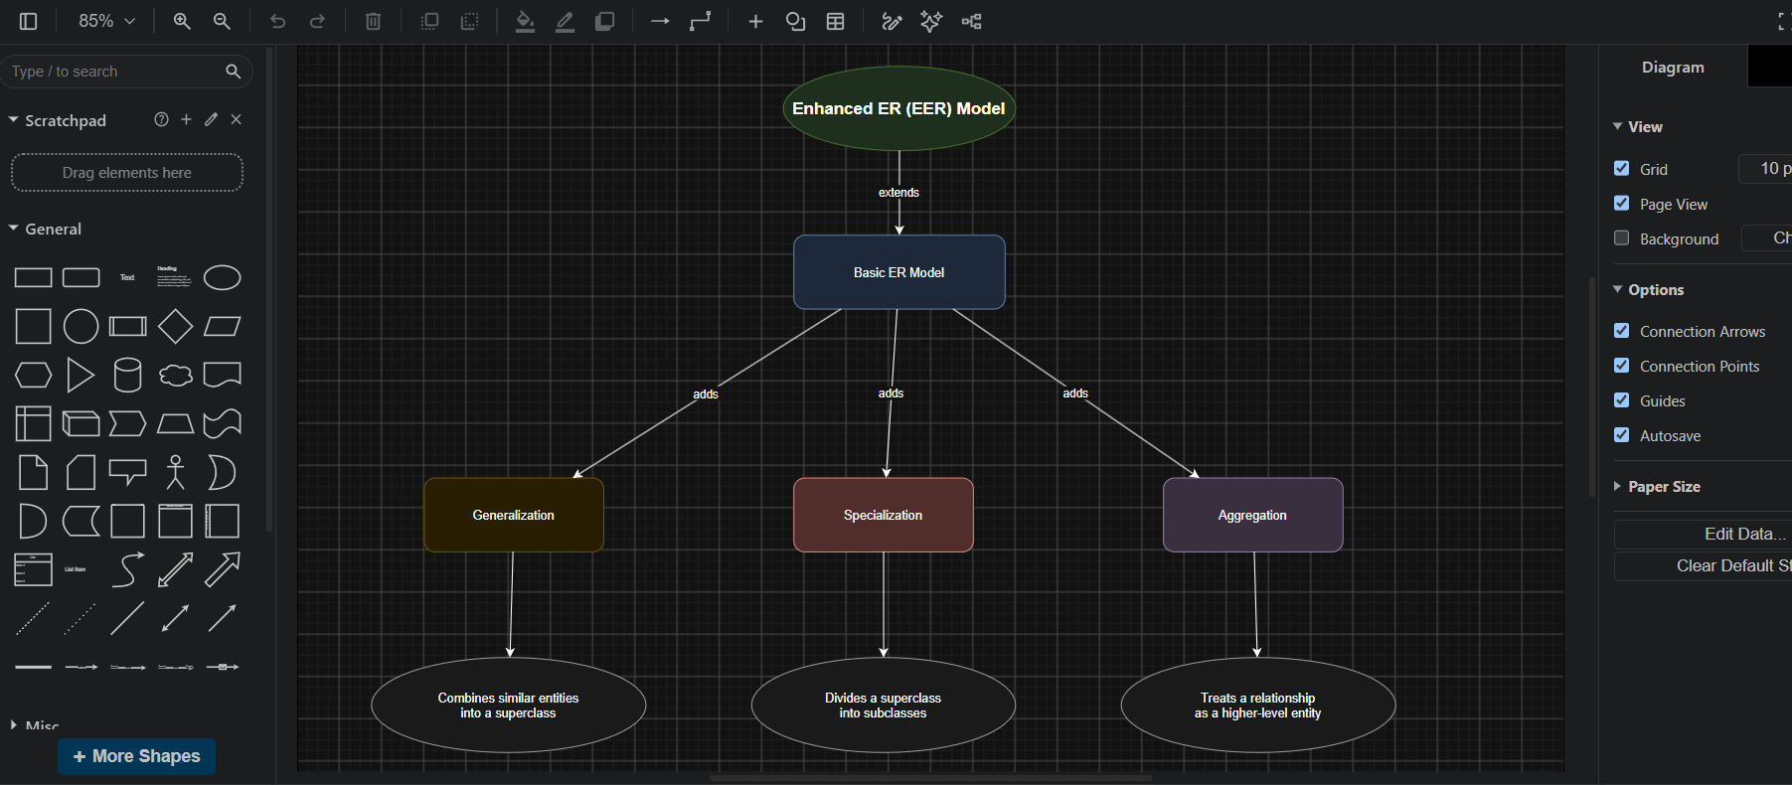
Tool used: https://app.diagrams.net/

The Enhanced Entity-Relationship (EER) Model extends the basic ER model by introducing advanced modeling concepts.
- Basic ER Model: Represents entities, attributes, and relationships.
- Generalization: Combines multiple similar entities into a single superclass based on common features.
- Specialization: Divides a superclass into multiple subclasses with unique characteristics.
- Aggregation: Treats a relationship between entities as a higher-level entity, allowing it to participate in other relationships.

7: Create a visual concept map for the DBMS software architecture, illustrating the flow from user request to data retrieval.

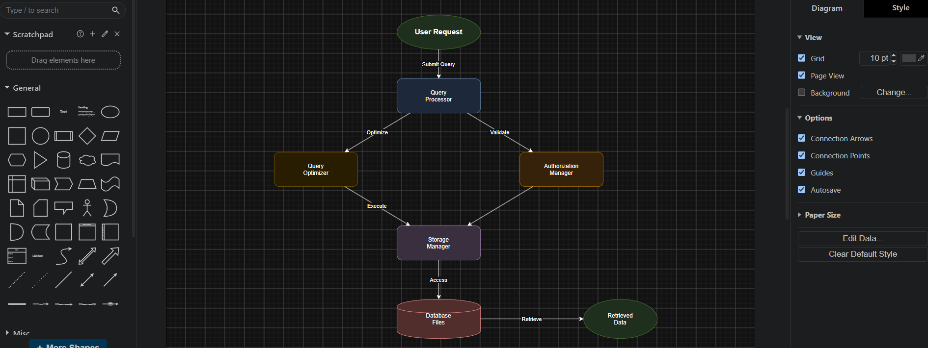
Tool used: https://app.diagrams.net/

The concept map illustrates the DBMS software architecture from user request to data retrieval. A user submits a query to the Query Processor, where it is optimized and validated. The Storage Manager accesses the Database Files to retrieve the required data, which is then returned to the user efficiently.

8: Map the data models discussed in CO1 to real-world applications and explain the suitability of each model.

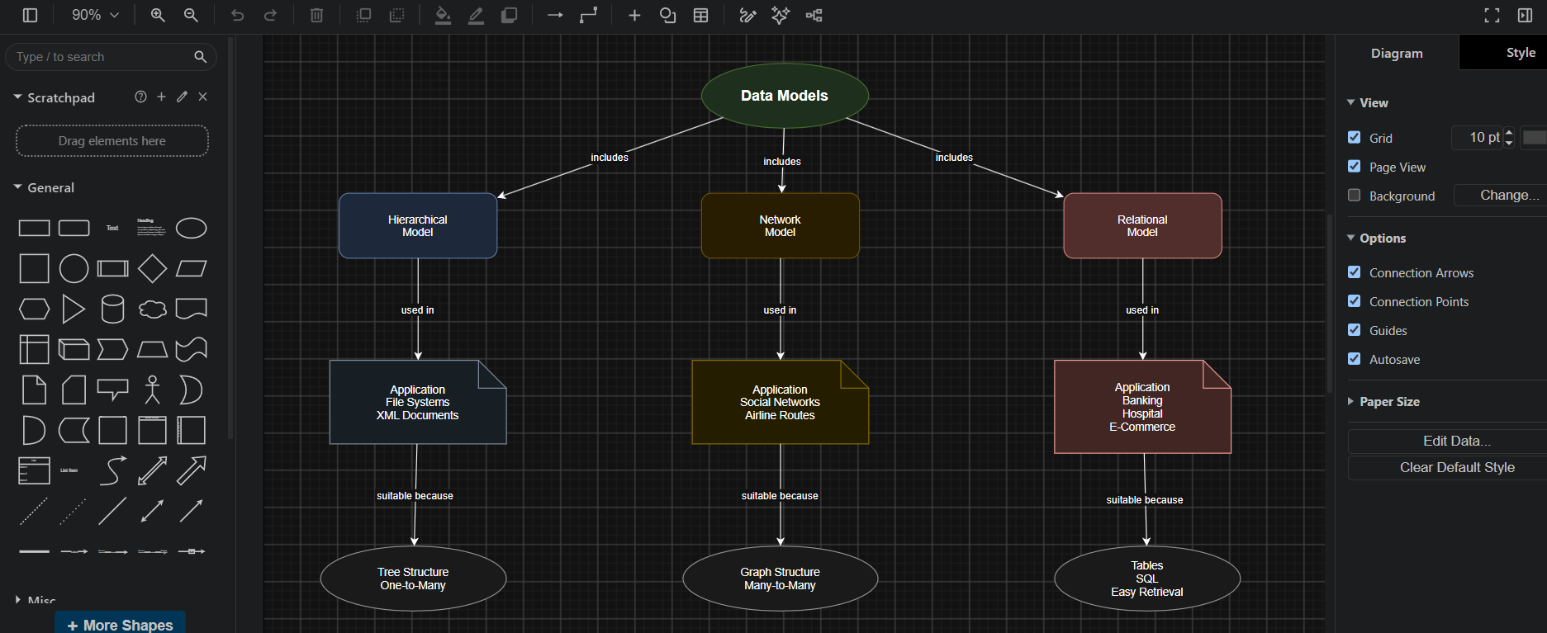
Tool used: https://app.diagrams.net/

This concept map compares the three data models with their real-world applications.
- Hierarchical Model is suitable for file systems and XML documents because it uses a tree structure with one-to-many relationships.
- Network Model is used in social networks and airline reservation systems because it supports many-to-many relationships.
- Relational Model is widely used in banking, hospitals, and e-commerce because it stores data in tables, supports SQL, and provides efficient data retrieval.

9: Construct a concept map for Schemas and Instances, showing how they relate to Physical and Logical Data Independence

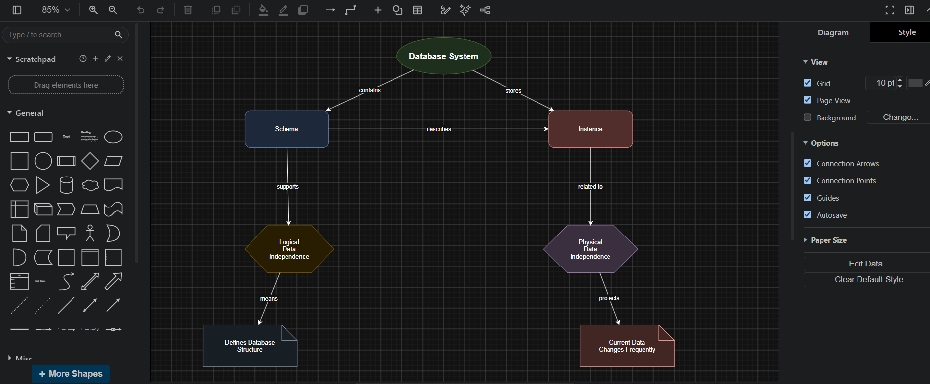
Tool used: https://app.diagrams.net/

This concept map shows the relationship between Schema, Instance, and Data Independence.
- Schema defines the structure of the database.
- Instance represents the current data stored in the database.
- Logical Data Independence allows changes to the logical schema without affecting user applications.
- Physical Data Independence allows changes in physical storage without affecting the logical schema or data.

10: Design a concept map for the roles and responsibilities in a DBMS environment: DBA, End User, Application Developer

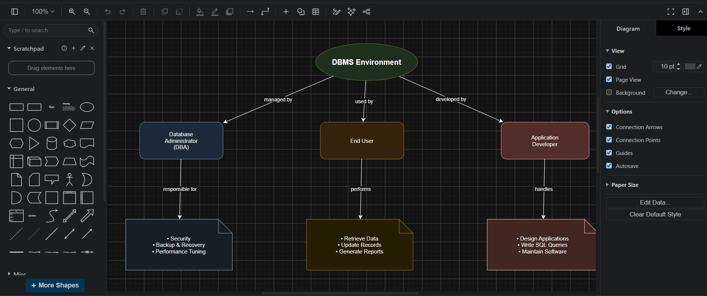
Tool used: https://app.diagrams.net/

This concept map shows the three main roles in a DBMS environment.
- Database Administrator (DBA): Manages database security, backup and recovery, and performance.
- End User: Accesses the database to retrieve, update, and generate reports.
- Application Developer: Designs database applications, writes SQL queries, and maintains software.
Concept Flow
DBMS Environment
→ managed by → DBA (Security, Backup, Performance)
→ used by → End User (Retrieve, Update, Reports)
→ developed by → Application Developer (Applications, SQL, Maintenance)
****

